TIPS FOR SPSS
Will Hopkins
AUT University
will@clear.net.nz
December 2006; minor updates to the advanced modeling sections April 2012.
Major Problem
- You can't copy graphs from SPSS into PowerPoint and take them apart. So any graphs for publications will have to be done with Excel or some other graphing software.
Importing Excel files
- You have to save as text and import as text if you have generated decimals in Excel. Otherwise SPSS won't display most results. You can't paste nominals directly, either. Sigh…
Simple Stats
- From the menu bar, select Analyze/Descriptive Statistics/Descriptives for simple stats.
- From the menu bar, select Analyze/Descriptive Statistics/Explore/Plots/Stem-and-leaf or Histogram
Reliability
- From the menu bar, select Analyze/Scale/Reliability Analysis.
- Select the trials (or items making up the factor, for alpha reliability). Keep the default model Alpha.
- Click Statistics, and select Descriptives for Item and Scale, Inter-item Correlations, Summaries Correlations, ANOVA Table F test, Intraclass correlation coefficient, the default Model Two-Way Mixed, the default Type Consistency, and 90% confidence limits.
- Most things are obvious in the output, but the typical error has to come from the ANOVA table. It is the square root (you have to do it manually) of the Mean Square for the Residual term.
- The intraclass correlation coefficient (equivalent to the average of all pairwise correlations) is the value for Single Measures. Cronbach's alpha is the value for Average Measures.
- The values for the typical error and intraclass correlation will differ a little from those in my spreadsheet for reliability, because I average consecutive pairwise trials, not all pairwise trials. Mine is more appropriate for test-retest reliability but wrong for alpha.
Validity
- From the menu bar, select Analyze/Regression/Linear.
- Select the criterion as the Dependent and the practical as the Independent.
- Click Statistics, and select Estimates, Confidence Intervals (sorry, can't choose 90%), Model fit and Descriptives.
- The defaults for options are OK.
- Click OK. What you want in the output should be obvious.

Advanced Modeling: Mixed Modeling
- These instructions are appropriate for modeling a randomized controlled trial. Use in conjunction with the data (multiliner for mixed.sav) zip-compressed folder of files for mixed modeling. The data consist of two groups (Exptal and Control) and three trials (1, 2, 3) representing pre, post1 and post2 measurements. The data have been set up with dummy variables xvarExp2 and xvarExp3, which have values of 0 for all levels except Trials 2 and 3 respectively for the Exptal group, where their values are 1. These will be used as fixed effects and random effects to estimate the mean Exptal-Control effect for Post1-Pre and Post2-Pre and the individual responses for those effects.
- From the menu bar, select Analyze/Mixed Models/Linear…
- Select Subjects (here, Athlete), Repeated (here, Trial), and Repeated Covariance Type (here, Compound Symmetry). Click Continue.
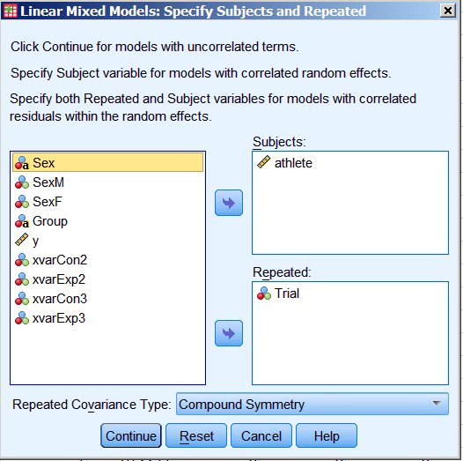
- Select the Dependent Variables (y), Factors (Group, Trial), and Covariates (xvarExp2, xvarExp3).
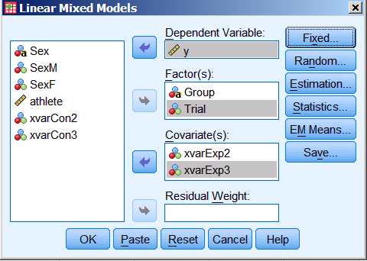
- Click Fixed... Select all four variables in the Factors and Covariates window, choose Main Effects (not Factorial), click Add, then Continue.
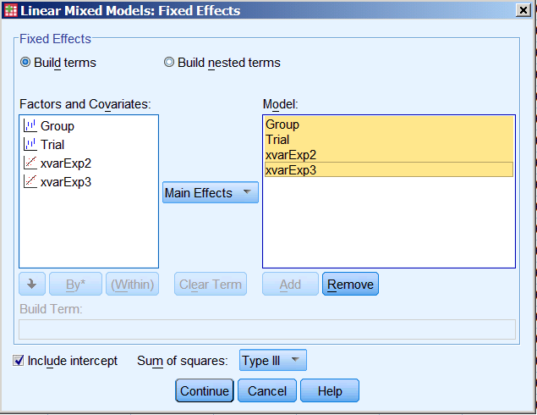
- Click Random…
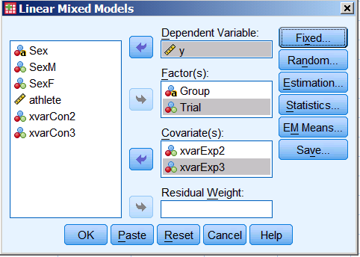
Keep the default Covariance Type (Variance Components). In the Factors and Covariates window, select xvarExp2, then click Add. Ditto xvarExp3. Or highlight both those covariates, choose Main Effects, and Add. In the Subject Groupings, select Athlete and put into Combinations. Click Continue.
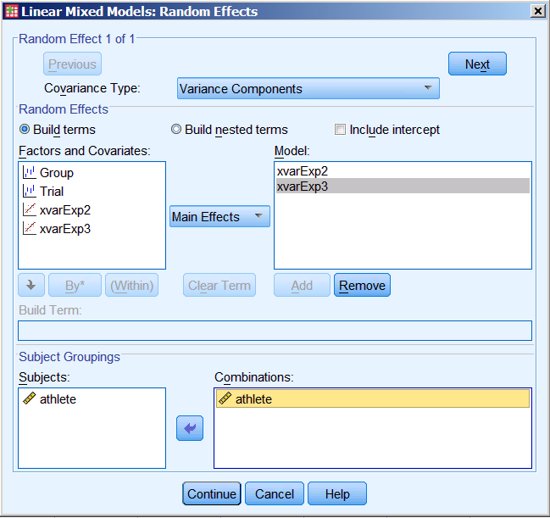
- Click Statistics…,
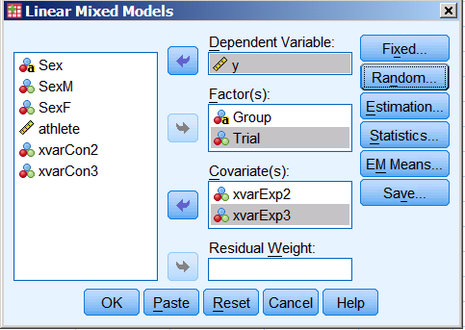
and under Model Statistics tick Parameter estimates and Tests for covariance parameters. And, of course, 90% confidence interval. Continue.
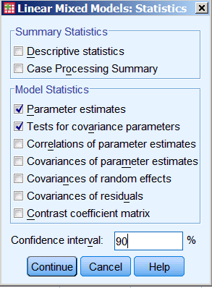
- Click OK.
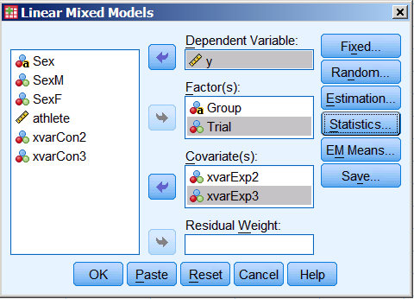
- The net fixed effects of the experimental treatment (Trial2-Trial1 and Trial3-Trial1 for Exptal-Control) are shown highlighted:
Estimates of Fixed Effects(b)

Parameter | Estimate | Std. Error | df | t | Sig. | 90% Confidence Interval
 |  |  |  |  |  | Lower Bound | Upper Bound
Intercept | 66.122155 | 2.492894 | 81.237 | 26.524 | .000 | 61.974409 | 70.269901
[Group=Control] | -.238309 | 3.131990 | 79.082 | -.076 | .940 | -5.451040 | 4.974422
[Group=Exptal ] | 0(a) | 0 | . | . | . | . | .
[Trial=1] | -.538972 | .289256 | 89.606 | -1.863 | .066 | -1.019727 | -.058217
[Trial=2] | -.102536 | .289256 | 89.606 | -.354 | .724 | -.583291 | .378219
[Trial=3] | 0(a) | 0 | . | . | . | . | .
xvarExp2 | 2.236971 | .704684 | 48.066 | 3.174 | .003 | 1.055089 | 3.418852
xvarExp3 | -.440789 | .489645 | 72.956 | -.900 | .371 | -1.256541 | .374964
a This parameter is set to zero because it is redundant.
b Dependent Variable: y.

- The variances representing individual responses are shown highlighted. You need to take the square root. Note also that these variances have been estimated without allowing for negative variance. The confidence limits need to be converted to those of normally distributed variables using the p value (highlighted), as per the controlled-trials spreadsheet. Negative variance then has to be converted to a negative standard deviation by changing sign before taking the square root. Overwhelmingly complicated!
Estimates of Covariance Parameters(a)

Parameter |  | Estimate | Std. Error | Wald Z | Sig. | 90% Confidence Interval
 |  |  |  |  |  | Lower Bound | Upper Bound
Repeated Measures | CS diagonal offset | 2.091733 | .312502 | 6.693 | .000 | 1.635999 | 2.674418
 | CS covariance | 181.833820 | 29.250519 | 6.216 | .000 | 133.720 | 229.946
xvarExp2 [subject = athlete] | Variance | 8.203848 | 3.112420 | 2.636 | .008 | 4.3954 | 15.3119
xvarExp3 [subject = athlete] | Variance | .499009 | 1.316057 | .379 | .705 | .006518 | 38.2027
a Dependent Variable: y.

Advanced Modeling: Analysis of a Binary Outcome
- I'm afraid this is impossibly complicated. Has anyone ever used this part of SPSS to do get a usable estimate of risk? I doubt it.
- Anyway, use the data in the zip-compressed folder of files for binary outcomes to work your way through these instructions. I generated the data with the binary-outcomes spreadsheet in the Excel workbook accompanying the article on Understanding stats via simulations. The dependent is Event, with values 0 and 1 in two control and exptal subjects defined by the variable Group. The predictor is some subject characteristic X, which I have recoded into a variable XM0SDp5 ("X with mean 0 and SD .5"), as per the next point. The variable ModeledP is the "true" probability that the event will occur for each subject, modeled from population values that are shown in the binary-outcomes spreadsheet. You can ignore this variable.
- Transform any numeric covariates by making new covariates with a mean of zero and a standard deviation of 0.5. Do it in Excel, not SPSS. This strategy is necessary to make any sense of the output. If there are certain values of the covariates (other than the means) at which you are interested in evaluating relative risk, create more new variables from the covariates so that the new variables have a mean of zero at the values of interest. Make sure they have SDs of 0.5, too.
- From the menu bar, select Analyze/Regression/Binary Logistic…
- In the Logistic Regression window that opens, select the dependent (an outcome variable having only two levels (0 and 1, female and male, etc.).
  - Select each covariate (predictor), then select those you want to interact by control-clicking on them, then click the >a*b> button.
  - If you have any categorical covariates, click on Categorical, click on the variable, choose Indicator (it should be the default), click on the Reference Category (e.g., if the levels are "control" and "exptal", control comes before exptal alphabetically, so if you want exptal-control, click on First), then don't forget to click Change. Click Continue.
- Back in the Logistic Regression window, click Options, select CI for exp(B) and make it 90%.
  - Select Display/At last step. Keep the default Include constant in model. Click Continue.
  - Click OK.
- Scroll to the bottom (ignore everything else). Exp(B) has the odds ratios for each effect, and the odds (not odds ratio) for the constant.
  - You now have to jump through various hoops to convert odds ratios into relative risks, which are more meaningful. You use the fact that odds = risk/(1-risk) = prob/(1-prob), or equivalently risk = prob = odds/(1+odds).
  - The odds ratios for categorical covariates are sort-of controlled for other covariates: that is, they are the odds ratios when there are equal numbers of subjects on the other levels of any other categorical covariates, but when the numeric covariates are zero. This is not what is usually meant by controlling for a numeric covariate. In fact, what you have here is the solution to the model, not what SPSS should provide, the so-called least-squares means. So make sure you have already transformed the numeric covariates to have a mean of zero (or to have a value of zero corresponding to any other values of the covariates(s) at which you want to evaluate the relative risk).
  - The value for Constant is the odds with the categorical covariates at their reference levels and numeric covariates at zero. The risk for subjects at this level or these levels is odds/(1+odds) = Exp(B)/(1+Exp(B). You can do the same thing to the confidence limits, if you want them. To get the risk at another level, multiply the Exp(B) for the constant by the Exp(B) for the other level. You now have the odds for the new level, so convert it to a risk using the same odds/(1+odds) formula. Sorry, now you can't do the same thing with the confidence limits. To get those, you will have to rerun the analysis and choose a new reference level.
  - Get the relative risk for the new level vs the reference level by dividing one risk by the other. The confidence limits for this risk have to come from my spreadsheet for confidence limits. Use the panel for log-normally distributed effects, and insert the relative risk and the p value (the value in the Sig. column).
  - To convert the odds ratios for the numeric covariates to relative risks, you can't just use Exp(B)/(1+Exp(B). Instead, you have to first convert the odds ratio of the covariate into a risk for someone who already has a certain level of risk. The most obvious levels are those of the categorical covariates. So, you multiply the odds for that level by the odds ratio for the covariate, then convert the resulting odds into a risk using the odds/(1+odds) formula. Its confidence limits come from the p value for the numeric covariate. Note that you have evaluated the effect of two SDs of the covariate. The smallest worthwhile relative risk for the effect of two SDs of a covariate is the same as what you would consider to be the smallest worthwhile effect between two levels of a categorical predictor.
  - If the risk is small (<20%) and the odds ratio times the risk is also small, you can interpret the odds ratio as a relative risk. The smallest worthwhile effect is ~1.1 or 1.2 (10% or 20% increased risk).

