SPORTSCIENCE · sportsci.org

News & Comment / Performance
Who Won the Olympics?
Stephen Seiler
Sportscience 14, 1-6, 2010 (sportsci.org/2010/ss.htm)
University of Agder, Faculty of Health and Sport, Kristiansand 4604, Norway. Email. Reviewer: Gordon Sleivert, Canadian Sport Centre Pacific, Richmond, BC V7B 0A2, Canada

The list of sports in the Winter Olympics has expanded dramatically in recent years, resulting in more medals for nations specializing in winter sports. Canada has emerged as a major Winter Olympic power and is a medal contender in virtually all sports. Smaller winter nations like Norway win most of their medals in a few disciplines, do not have the facilities or resources to develop international contenders in all the winter Olympic sports, and seem to be falling behind in the total medal race. The Winter Olympics have responded to television audiences by introducing exciting events like snowboarding, ski cross, and short track speed skating. No country has profited more from this revamping of the Winter Olympic program than the United States, which won almost half of its record number of medals in these non-traditional events. The Olympic Games as a spectator event depend on their TV friendliness, which in turn influences the choice of events that are added to the Olympic schedule. More speed, bigger tricks, and more head to head racing instead of racing against a clock are hallmarks of this evolution in new and traditional winter Olympic sports. The challenge for Olympic federations and research institutions is to adapt and embrace this evolution as they contribute to enhancing the performances of their athletes.
Reprint pdf · Reprint doc

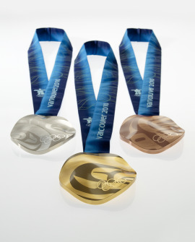
The 2010 Winter Olympics are fresh in our memory. But already across the winter sports globe, various Olympic federations are taking stock of their results on behalf of their national governments, and analyzing what they will mean for future high performance development strategies, funding, and athlete support processes. As Stephen Hume recently wrote: “Governments are invested not out of altruism, but out of self-preservation. They invest because sport matters so deeply to their citizens.” Canada spent $578 million on construction and $1.78 billion to run the 2010 Olympics. Canada also invested $110 million directly on athlete development in their bid to “own the podium.” The Norwegian Olympic Committee proposed a study to quantify the ”dollar price” of winning Olympic medals among the various Olympic powers, with backing from the IOC. Unfortunately, making these calculations is somewhere between hard and almost impossible. To date, most OCs have shied away from relinquishing such data. What seems clear is that Olympic medals cost far more than their weight in gold. Meanwhile, Vladimir Putin announced a full investigation into the reasons for the failure of the Russian team to garner more medals in Vancouver. As 2014 host nation, their results were uncharacteristically dismal. Given the scandals of recent Olympics, this may be an indicator that the drug testing program is working (no positive drug tests reported from Vancouver). For sport scientists, the Olympics remain a quadrennial showcase and testing ground for the cutting edge in all aspects of sport performance, from materials science to altitude training, to sport psychology. For everyone else, the Winter Olympics seem to contribute to nation building. Indeed they contribute more to national pride than they used to thanks to an expanded event profile that has brought the Winter games out of the forest and into the X games arenas that TV viewers prefer (except in Norway, where two hour uninterrupted XC ski races still pull massive TV ratings). So, as a sport scientist with research interests in elite performance development, an occasional invited speaker to other Olympic federations, an emigrant from the USA to Norway, and an avid fan of the Olympics, I was compelled to try to make my own assessment of the 2010 results.

Making Sense of the Medal Count
Eighty-two nations sent teams to the winter Olympics. The entire northern hemisphere shows up. Africa, Latin America, and much of the middle East and Asia understandably stay home (excepting the occasional Kenyan XC skier or Ghambian slalom skiing “snow leopard”). Fifty-six of the nations that did compete went home without medals. So, only about 33% of Winter Olympic participant nations actually won medals. Five nations grabbed over 50% of all the medals. The normal distribution does not apply to the Olympic medal race. By comparison, the Summer Olympic medals are slightly more evenly distributed with 86 of 204 nations winning medals in 2008 (42%). In both Winter and Summer Olympics, a few nations have always dominated, but in the Winter Olympics the short list of major powers is even shorter.
The final medals table can be interpreted in different ways. The USA won the total medal race as US broadcaster NBC no doubt repeated ad nauseum. Canadian broadcasters ultimately reveled in the gold medal count. Counting medals is a crude measure of success that doesn’t take into account a lot of important variables. The US has 300 million people, so their 37 medals were spread pretty thin on a per capita basis. However, only 35 states contributed athletes to the Vancouver team, and over half of those came from just eight winter sport states (e.g. Colorodo, Minnesota, and Wisconsin). The entire population of Canada is 33 million or so. Assuming all of Canada is one big “ice and snow state”, then the US and Canadian medal take was probably pretty even per “access adjusted” capita. But what about Norway? With its scant 4.6 million population, Norway’s 23 medals come out at about five medals per million inhabitants. No country can match that (Figure 1). In reality though, medals per capita is also a misleading metric, no matter what country we apply the math to. There is no clear relationship between country population and talent production. Indeed, the “critical mass” for being internationally competitive in even the biggest sports seems quite small, as world basketball power Lithuania demonstrates. Every potential talent in Norway does not have equal access to the unique combination of stable winter, great training conditions, supportive ski club, local expertise, etc. that make a “talent factory”. When talent, tradition, expertise, facilities, and opportunity coalesce, one small area can foster a disproportionate number of future medal winners over time. This seems true whether one talks of Jamaica in sprinting, Norway in XC skiing, or Wisconsin in speed skating. Big dreams begin in local arenas. The work of national governing bodies is to support the health of these local grass roots talent development hubs. The work of Olympic federations is to guide and support athletes in their transition from national talent to international contender, and hopefully to Olympic medal winner.

Figure 1. Vancouver Winter Olympic medals per million inhabitants.
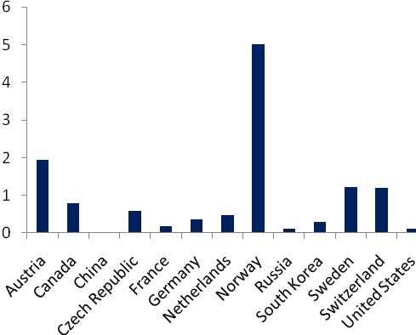

Small countries like Norway may actually have some advantage when it comes to “converting” talent to medals; they can implement national talent development strategies more easily and focus resources more effectively. Gordon Seivert from Canada points out that larger countries like Canada and the US have regional differences in support mechanisms in place for talent development. For example, the provincial government of British Columbia in Canada has committed substantial funding to coaching support all along a path from regional, to provincial, to national teams. In other regions of Canada there is little investment and hence lower proportionate participation from these regions on Canadian national teams. For example, British Columbia has 12% of Canada’s population, but made up 17% of their Olympic team and won 23% of their medals in 2010.

Everyone is Winning More Medals
The total of 14 gold medals won by Canada was an all time high. So was the total of 37 medals won by the USA. But, both of those new records should have an asterisk beside them. As Figure 2 below shows, the total number of Olympic events and contested medals has exploded in recent years.

Figure 2. Total Winter Olympic medal events 1968-2010.
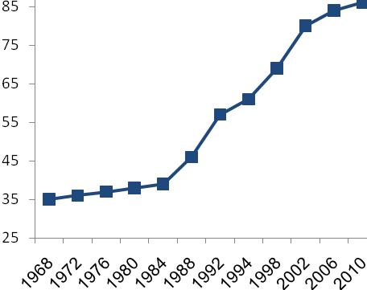

Taking this fact into account, the 14 golds of 86 possible (16%) won by Canada are a remarkable achievement, but not nearly as dominating as the 13 golds of 37 possible (35%) won by the USSR in 1976. There actually seems to be more performance parity in the Winter Games today based on the distribution of medals. New high speed, high breath-hold factor events like skeleton, snowboard cross, ski-cross, short track speed skating, and snow board half-pipe have been added. Even traditional Nordic disciplines like XC skiing, and biathlon have been recharged by adding mass start and “sprint” events. Thus, even if the inter-nation medal distribution was static, everyone could claim success as their total medal count tended to increase over time.
If national Olympic federations want to evaluate their strategies and Olympic success in a historical context, they have to account for this event expansion. I have chosen to analyze the results of four countries based on my own biases. The US and Norway are both “home” countries for me. Canada was the host nation and a nation on the rise in winter sports as we shall see. I have thrown in Sweden as a neighbor to Norway that is comparable in size and winter sport tradition, but not Olympic Winter Games success. I have written about Sweden and Norway in this journal before, so I will only touch on this tussle among Nordic nations here. Figure 3 supports what Figure 2 predicts; all the big winter sport nations are winning more medals.

Figure 3. Total medals won 1968-2010.
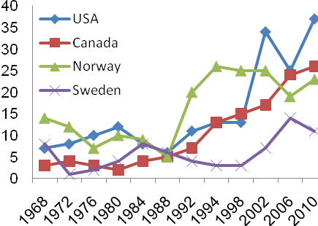

One might argue that total medals is not an appropriate metric, since gold is worth more than silver, which is worth more than bronze. If we try to account for both medal “value” and the issue of medal event expansion, we can give gold 3 points, silver 2, and bronze 1 point, and express country by country results like a car manufacturer might express sales, in terms of “share of total medal points”. Those results are shown in Figure 4. The trend lines lose some of their trendiness, but there are some stories in the data if we tweeze them out.

Figure 4. Share of total medal points won 1968-2010 (%)
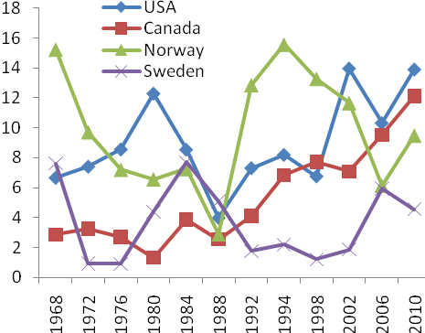

The Canadian Climb
Figure 4 shows that Canada has slowly but surely climbed out of an Olympic medal abyss in the 70s and 80s to become a winter sports superpower today. They have not only kept pace with the event expansion by winning more medals, but they have taken a bigger share of the total medals. Clearly the host nation effect has played a role, but the Canadian upswing started 10 years before the Olympics were awarded to Vancouver. Stronger Olympic federation support programs, centralization of national development squads around infrastructure hubs, as well as a large increase in direct athlete financial support seem to be important components of this success. If we consider breadth of success, Canada won the Olympics by winning gold medals in nine of 15 sports. They also reported an all-time high 71 top eight finishes. Canada won medals in all of the skating sports. We can expect that there is a synergistic effect of athlete recruitment, talent exchange and technology transfer within the different skating disciplines. They were also big medal winners in the new freestyle skiing and snowboard events.
For the privately funded Canadian Olympic Committee, the challenge in the next quadrennium will be to maintain these organizational and infrastructural improvements and stay “among the top performing sporting nations in the world.” In Vancouver, Canada failed to convert the home mountain advantage to medals in the Alpine events, and remain out of medal contention in most Nordic events. But overall, the Canadian “Own the Podium (OTP)” program has to be considered a huge success. So, what did they do? Gordon Seivert, working with top sport in British Columbia, describes OTP as ”an arms-length technical agency that invested in: top coaching, improving the daily training environment, increasing training camp opportunities, improved sport medicine support, and investment in science and technology. OTP pooled money from the COC, Sport Canada, provincial governments, and corporate Canada. Resources were allocated based on the technical plans of target winter sports, their track record of success, and organizational readiness to take their program to the next level. For its part, Canadian Olympic Committee focused its efforts on Games time readiness and helping finish preparation to enhance medal conversion rates (i.e. converting top five world rankings into medals).”
Like other Olympic federations, the COC will likely go in discipline by discipline to see where they can improve their assistance of athletes, focus resources, or in some cases, throw in the proverbial towel? With top eight finishes in every Olympic sport, towel throwing seems highly unlikely for this new winter Olympic superpower. Indeed, Sleivert confirms that having a successful Winter Olympics has solidified funding from provincial and federal governments to continue investing in Canadian sport performance. Success breeds success.

Nordic Norway
Norway is the all time leader in total Winter Olympic medals. This Olympics they climbed over the 100 mark for total gold medals since 1924. So, it is fair to say that much of Norway’s Winter Olympic success is a product of geography and tradition. But, over half of Norway’s all-time gold count has come since 1992. Here we will pick up the story from 1968. When the Winter Olympics became serious in the 70s and the USSR and East Germany took center stage, traditional Nordic sport countries like Norway saw their share of medals dwindle as their amateur athletes, with no funding and poor infrastructure, lost ground to the USSR and East Germany. For Norway the crisis peaked in 1988 when they did not win a single gold for the first time in Winter Olympic history. Norway’s Olympiatoppen was born. Since 1992, Norway’s Olympic results (both Summer and Winter) have dramatically improved. It is tempting to try to partial out the “Olympiatoppen effect” on Norwegian elite sport, but obviously difficult to quantify. The Norwegian Top Sport Center and Norway’s Olympic athlete development program shares many features that have been embraced by most sporting nations: dedicated facilities for elite athlete training, economic support to full time athletes, coach education, sports science research, medical support, and a hierarchical competition system that channels talents towards international performance (Andersen, 2009). However, Olympiatoppen has built itself primarily as a learning organization. Both the physical and organizational design of Olympiatoppen and the Norwegian Top Sport Center is focused on breaking down cultural barriers across sport disciplines and creating an arena where information, ideas, and experience can be exploited across sports. The Norwegian Olympic center organizational structure is very flat and involvement with athlete development is very hands-on. Training practice is built on a foundation of traditional research but adjusted by constant, mindful attention to individual responses and a performance development model described as “success through small, intelligent failures” (Andersen, 2009).
In Norway, there is general agreement that the development of the National Top Sport Center and the Olympiatoppen cross-disciplinary learning model contributed to the Norwegian medal surge in the last 20 years, highlighted by Norway’s record performances in 1994 when they were the host nation. Even eight years later, they won 13 gold medals, matching the then Soviet owned record from 1976. The Norwegian Olympic Federation has explicitly stated that their goal is to be among the top three nations in the Winter Olympics based on total medals, and their aggressive prognosis for medals in 2010 was 20-25. After an off year in 2006 where they won only two gold, Norway regained their former position as best of the small nations (and second in Europe) in 2010 with nine gold and 23 total medals. But the Norwegian ”medal chase” strategy is very different from the Canadian or American. While these large countries send athletes in every Olympic discipline, Norway does not invest resources on events where it does not see itself as a clear present or future medal contender. For example, in the traditional winter sport of figure skating, Norway has resigned itself to the fact that the three medals won by figure skater Sonja Henie in the Games of 1928, 1932, and 1936 will be the last for Norway in the discipline that she helped develop. With similar strategic choices, Norway did not even compete in events like short track speed skating and bobsled, where recruitment is too limited, the performance gap up to the best nations too large, and national facilities too limited. Instead, the rise or fall of the country as a winter Olympic nation continues to rest disproportionately on the shoulders of their Nordic and alpine skiers. In these disciplines, athlete recruitment is strong, training conditions are good, and coaching expertise is plentiful (it would seem that XC ski coaches are Norway’s third largest export behind oil and salmon). Every aspect of performance is studied and supported, from ski design to research on wax composition and ski-snow frictional interaction, to altitude training. Much of this work is outsourced to sport science departments at universities, or research consortiums. In Vancounver, Norway did manage to take at least one medal in seven different sports. But, of their nine gold medals, 8 were won in the two endurance disciplines of XC skiing and biathlon. Once a source of multiple medals, Norway has also fallen well behind in speed skating since 1994.
So, Norway’s position as a winter Olympic power rests on a narrowing platform. With 26, 25, 25, 19, and 23 medals won in the Games since 1994, the absolute medal count for Norway has remained stable and high over 2-3 generations of star performers. This suggests that the restructuring after 1988 has helped enhance talent development and improve competitiveness at the highest levels of international sport. But even correcting for some sickness and ski waxing mistakes in 2006, their percentage of the total medal count has decreased as the number of events has increased (Figure 4).
As the number of medal sports expands and the composition of the Olympic menu changes, Norway will have to broaden its platform if it is to compete among the top three winter nations. The Olympic federations of small winter sport powers like Norway and Austria will look for strategic cross-over possibilities where existing technology and coaching expertise can be applied to new disciplines, like ski-cross (two medals in 2010 to Norway). This implies ensuring that talented athletes with backgrounds in sports like traditional alpine skiing can be optimally supported in their transition to new arenas.

Ski Sweden Ski
In recent years, Norwegians have taken a kind of perverse pleasure in comparing Olympic medals with Sweden. The “little brother” to Sweden historically and bitter rival on the XC ski tracks over the years, Norway has enjoyed disproportionate winter Olympic success in recent decades, while Sweden’s Olympic Committee has seen its program languish. As Figures 3 and 4 show, the Norway-Sweden medal gap has narrowed substantially since 1998, when I first compared them.
The Swedes have focused on what they do best, and rebuilt their XC ski team to be a world beater by increasing funding, infusing their coaching ranks with fresh talent (including Norwegian coaches), and improving their material support program. Seven of their 11 medals in Vancouver were won in XC skiing, and another gold was won in biathlon, which is XC skiing with periodic stops for target shooting. These changes have made for a much more exciting rivalry between these two countries in the sport where they have both enjoyed great Olympic success. In 2006, Sweden won the XC ski war. In 2010 it was Norway, but the medal race was close. In the winter Olympics, when Sweden skis to gold, chances are good that it will mean one less gold for Norway.

USA and the X Games Factor
USA is not a winter sports nation: it is a team-sport nation, or more broadly a ball-sports nation. In recent years, it has also become an X games nation, with former “fringe” sports like skateboarding and ski cross going main stream on the backs of young, talented personalities like Shaun White. Winter sports have reaped benefits as sponsor income has followed TV success. After being stable and mediocre for 30 years, the US medal take in the last three Winter Olympics has exploded (Figure 3).
The medal distribution suggests that this is not just the positive after-effects of a 2002 host nation surge. Fifteen of USA’s 37 medals were won in new TV friendly sports short track speed skating, freestyle skiing, and snowboarding. The Winter Olympics have become more exciting to watch for forest loving Norwegians and dash and crash loving Americans alike. Clearly though, no Olympic federation has profited more from the revamping of the Winter Olympics sport menu than the USOC. Good television, not good sport science, is the most powerful influence on the future of the Olympic Games. Shorter event distances, more acrobatics, and more head to head racing instead of racing against a clock are hallmarks of this evolution. The challenge for Olympic federations and for sport research institutes is to adapt and embrace these new sports.

References
Andersen, S.A. (2009). Stor suksess gjennom små, intelligente feil. Erfaringsbasert kunnskapsutvikling i toppidretten. Tidsskrift for Samfunnsforskning 50, 427-461.
Published March 2010
©2010

